~Asia-China-Mirror-Yuan Dynasty-Bloom And Bird Pattern Bronze Mirror

This Yuan Dynasty bronze mirror (141 mm. dia., 4.5 mm. deep) dates to the empire established by Kublai Khan, the leader of Mongolian [Borjigin](http://en.wikipedia.org/wiki/Borjigin) clan, 1279-1368. It is in the shape of a lotus flower recalling its Buddhist significance as Bodhi, the state of total mental purity and spiritual perfection, and the pacification of our nature. It has eight petals corresponding to the Noble Eightfold Path of the Good Law. It is the lotus found at the heart of the GarbhadhatuMandala, being the womb or embryo of the world. The inner ring of the lotus consists of two phoenixes above a holy mountain. The outer ring has four rampant animals signifying the passage of time separated by pairs of orioles carrying clusters of grapes signifying constancy and the fruits of a good marriage, a motif that was also incorporated into the "lion and Grapes" mirrors.

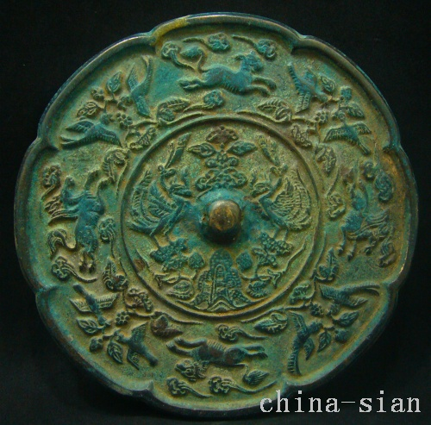

Diameter 141  mm     Deep  4.5  mm